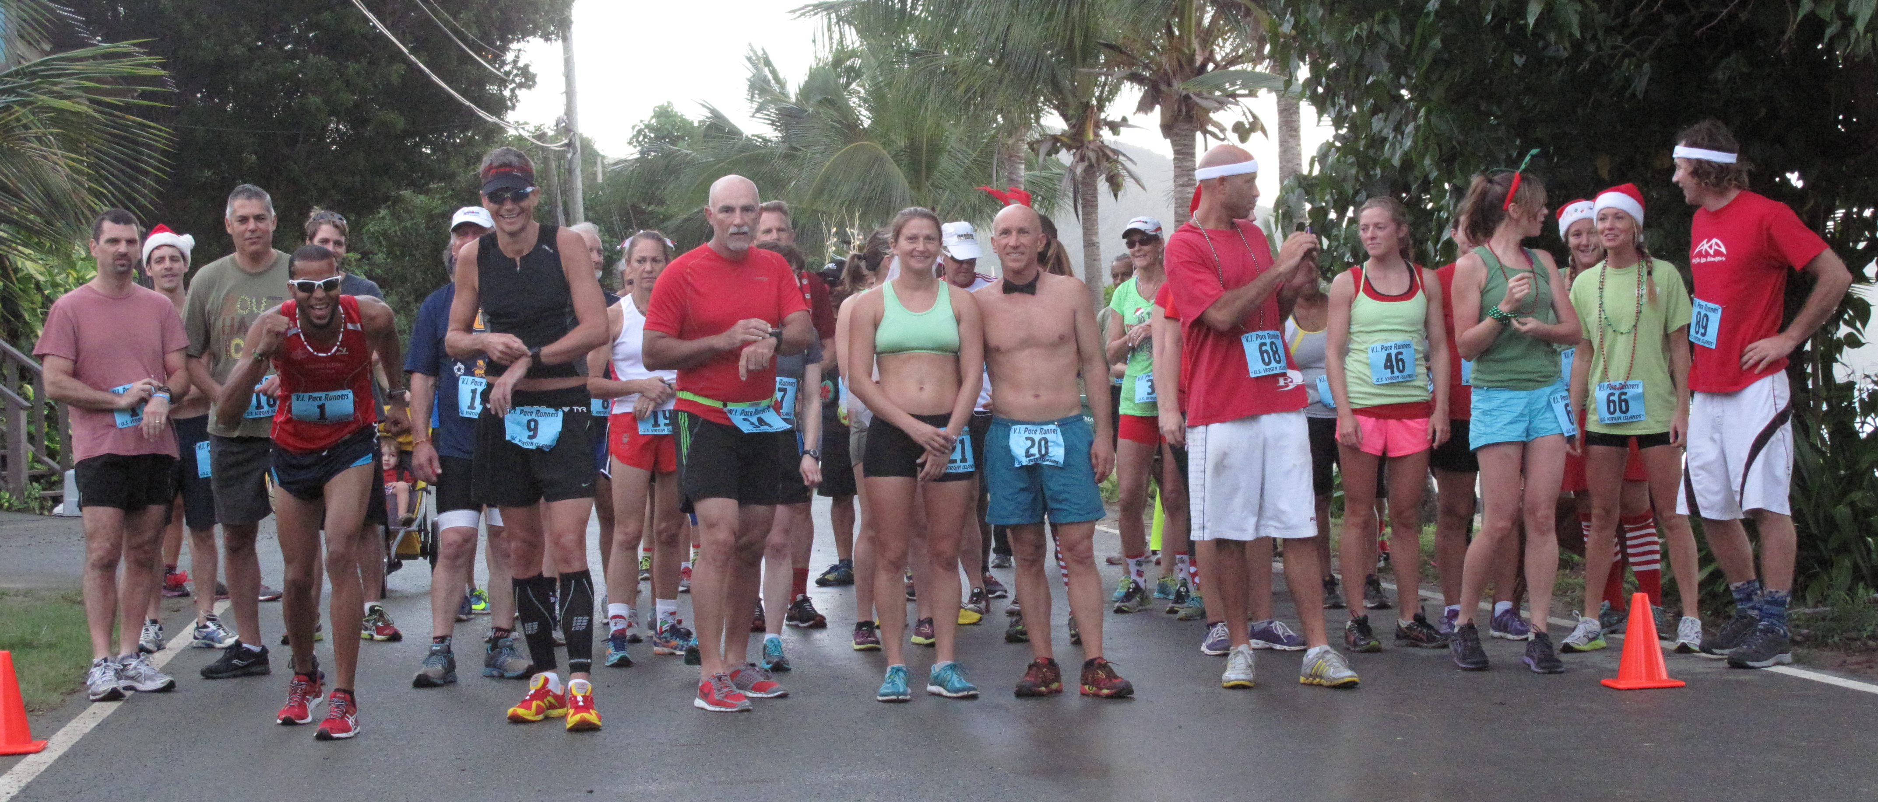
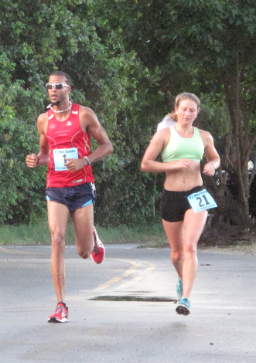
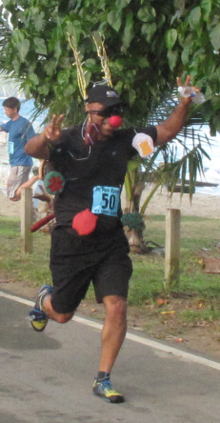
V.I.Pace Runners Bulletin
December 22, 2013
Cane Bay 5Miler…last race of the year…festive…
The Cane Bay 5Mile Road Race is traditionally the last Virgin Islands Pace Runners race for the year on its St. Croix Calendar. This year saw runners and walkers take advantage of an added attraction, the “Jingle Bell” run/walk. Dozens of them signed up to compete for top honors in the race and to win one of the ten turkeys provided by sponsor L N L Publishing.
Fresh off their victories in the St. Croix International Marathon and the V.I. Half-Marathon last Sunday, Juan Robles and Bridgett Campbell made the race their recovery run as they ran together at conversational pace the entire five miles. Robles was the overall winner of the race with a time of 34:53 to win the special “Jan Mitchell” glass award and a turkey; Campbell was the first female and second overall in 34:54, she too won the medal and a turkey. The top ten males and females won the glass awards and won the raffle of a half-dozen turkeys. Angelo Espinosa and Carol Murphy each won a turkey for the best jingle bell costume.
Coming up for January on the V.I.Pace Runners calendar: The 27th Annual Children Race…a half-mile race for boys and girls 13 and under at the start of the Crucian Christmas Festival Children’s Parade on January 3 and the 32nd Annual 3Kings Mile open to all ages at the start of the adult parade on January 4…both races are in Frederiksted.
Full results for the Cane Bay 5Mile…Jingle Bell Run/Walk can be found: http://virginislandspace.org
Later in the January the annual Martin Luther King Fort-To-Fort Memorial Run will take place on Sunday January 19. This endurance run is in honor of the famed civil rights advocate, it not a race, it is a group run for those who are trained to run the 15.5 mile distance.
The St. Croix Scenic 50Mile run will be held on January 26.
For information logon to: http://virginislandspace.org call: 340-643-2557 email: wallacewilliams@msn.com

********** MALE OVERALL RESULTS ***********
PL NAME AGE FROM TIME
1 | JUAN Robles | 24 | St.Croix | VI |  | 34:53
2 | MIKE Klein | 48 | Jolly Roger |  |  | 37:53
3 | TROY Holloway | 50 | St.Croix | VI |  | 37:54
4 | JAY Gleason | 39 | St.Croix | VI |  | 38:46
5 | SCOTT Fricks | 51 | St.Croix | VI |  | 39:50
6 | MYRON Baker | 65 | Accord | NY |  | 42:26
7 | SEBASTIAN Franks | 31 | St.Croix | VI |  | 43:34
8 | NIKOLOS Franks | 29 | St.Croix | VI |  | 43:36
9 | STEVE Hocking | 35 | Valdez | AK |  | 44:07
10 | WHITNEY Kemper | 65 | St.Croix | VI |  | 44:37
11 | GREG Schmalz | 48 | New Paltz | NY |  | 45:53
12 | YAN Solomon | 45 | Jolly Roger |  |  | 45:54
13 | CHRIS Doyle | 38 | St.Croix | VI |  | 46:27
14 | WILL Franks | 66 | St.Croix | VI |  | 47:33
15 | MARK Kennedy | 64 | St.Croix | VI |  | 47:42
16 | PATRICK Wheeler | 32 | Sunnyvale | CA |  | 48:01
17 | TEDDY Seymour | 70 | St.Croix | VI |  | 51:57
18 | MERVIN Mills | 45 | St.Croix | VI |  | 53:42
19 | ANGELO Espinosa | 48 | St.Croix | VI |  | 54:20
20 | LARRY Williams | 71 | St.Croix | VI |  | 59:

********** FEMALE OVERALL RESULTS***********
1 | BRIDGET Campbell | 30 | Jolly Roger |  |  | 34:54
2 | THERESA Harper | 40 | St.Croix | VI |  | 37:16
3 | SISSELL Holloway | 23 | St.Croix | VI |  | 40:06
4 | ANA Gutierrez | 52 | St.Croix | VI |  | 40:12
5 | KATIE Wheeler | 30 | Sunnyvale | CA |  | 43:41
6 | DULCIE Crowther | 44 | St.Croix | VI |  | 44:01
7 | LAURA Johnson | 35 | Valdez | AK |  | 44:13
8 | JEN Strum | 30 | St.Croix | VI |  | 45:01
9 | SUE Klein | 47 | Jolly Roger |  |  | 46:11
10 | LAVERNE Fredericks | 49 | St.Croix | VI |  | 50:33
11 | WHITNEY George | 26 | St.Croix | VI |  | 53:06
12 | KIRBY Jackson | 29 | St.Croix | VI |  | 53:07
13 | ASHLEY Ruffo | 26 | St.Croix | VI |  | 53:09
14 | KAITLYN Murphy | 21 | St.Croix | VI |  | 53:56
15 | CAROL Fricks | 54 | St.Croix | VI |  | 53:57
16 | LIZ Whitcher | 24 | St.Croix | VI |  | 56:14
17 | SAZA Seaver | 32 | St.Croix | VI |  | 56:15
18 | KATHEERINE pugliese | 47 | St.Croix | VI |  | 56:47
19 | ASHLEY McKinnon | 42 | St.Croix | VI |  | 58:07
20 | KRYSTAL Lanclos | 20 | St.Croix | VI |  | 58:53
21 | WENDY Solomon | 40 | St.Croix | VI |  | 1:01:41
22 | CAROLYN Lanclos | 54 | St.Croix | VI |  | 1:10:34
23 | GISELLE Evora | 41 | St.Croix | VI |  | 1:12:29
24 | JOYCELYN Cazaubon | 44 | St.Croix | VI |  | 1:15:41
25 | PRINCESS Lanclos | 22 | St.Croix | VI |  | 1:36:45

MALE AGE GROUP: 20 - 29
1 | 12 | NIKOLOS Franks | 29 | St.Croix | VI | 43:36

FEMALE AGE GROUP: 20 - 29
1 | 8 | SISSELL Holloway | 23 | St.Croix | VI | 40:06
2 | 28 | WHITNEY George | 26 | St.Croix | VI | 53:06
3 | 29 | KIRBY Jackson | 29 | St.Croix | VI | 53:07
4 | 30 | ASHLEY Ruffo | 26 | St.Croix | VI | 53:09
5 | 32 | KAITLYN Murphy | 21 | St.Croix | VI | 53:56
6 | 35 | LIZ Whitcher | 24 | St.Croix | VI | 56:14
7 | 39 | KRYSTAL Lanclos | 20 | St.Croix | VI | 58:53
8 | 45 | PRINCESS Landclos | 22 | St.Croix | VI | 1:36:45

MALE AGE GROUP: 30 - 39
1 | 6 | JAY Gleason | 39 | St.Croix | VI | 38:46
2 | 11 | SEBASTIAN Franks | 31 | St.Croix | VI | 43:34
3 | 15 | STEVE Hocking | 35 | Valdez | AK | 44:07
4 | 22 | CHRIS Doyle | 38 | St.Croix | VI | 46:27
5 | 25 | PATRICK Wheeler | 32 | Sunnyvale | CA | 48:01

FEMALE AGE GROUP: 30 - 39
1 | 13 | KATIE Wheeler | 30 | Sunnyvale | CA | 43:41
2 | 16 | LAURA Johnson | 35 | Valdez | AK | 44:13
3 | 18 | JEN Strum | 30 | St.Croix | VI | 45:01
4 | 36 | SAZA Seaver | 32 | St.Croix | VI | 56:15

MALE AGE GROUP: 40 - 49
1 | 4 | MIKE Klein | 48 | Jolly Roger |  | 37:53
2 | 19 | GREG Schmalz | 48 | New Paltz | NY | 45:53
3 | 20 | YAN Solomon | 45 | Jolly Roger |  | 45:54
4 | 31 | MERVIN Mills | 45 | St.Croix | VI | 53:42
5 | 34 | ANGELO Espinosa | 48 | St.Croix | VI | 54:20
FEMALE AGE GROUP: 40 - 49
1 | 3 | THERESA Harper | 40 | St.Croix | VI | 37:16
2 | 14 | DULCIE Crowther | 44 | St.Croix | VI | 44:01
3 | 21 | SUE Klein | 47 | Jolly Roger |  | 46:11
4 | 26 | LAVERNE Fredericks | 49 | St.Croix | VI | 50:33
5 | 37 | KATHEERINE Pugliese | 47 | St.Croix | VI | 56:47
6 | 38 | ASHLEY McKinnon | 42 | St.Croix | VI | 58:07
7 | 41 | WENDY Solomon | 40 | St.Croix | VI | 1:01:41
8 | 43 | GISELLE Evora | 41 | St.Croix | VI | 1:12:29
9 | 44 | JOYCELYN Cazaubon | 44 | St.Croix | VI | 1:15:41

MALE AGE GROUP: 50 - 59
1 | 5 | TROY Holloway | 50 | St.Croix | VI | 37:54
2 | 7 | SCOTT Fricks | 51 | St.Croix | VI | 39:50

FEMALE AGE GROUP: 50 - 59
1 | 9 | ANA Gutierrez | 52 | St.Croix | VI | 40:12
2 | 33 | CAROL Fricks | 54 | St.Croix | VI | 53:57
3 | 42 | CAROLYN Lanclos | 54 | St.Croix | VI | 1:10:34

MALE AGE GROUP: 60 - 99
1 | 10 | MYRON Baker | 65 | Accord | NY | 42:26
2 | 17 | WHITNEY Kemper | 65 | St.Croix | VI | 44:37
3 | 23 | WILL Franks | 66 | St.Croix | VI | 47:33
4 | 24 | MARK Kennedy | 64 | St.Croix | VI | 47:42
5 | 27 | TEDDY Seymour | 70 | St.Croix | VI | 51:57
6 | 40 | LARRY Williams | 71 | St.Croix | VI | 59:34

FEMALE AGE GROUP: 60 – 99

***********MALE AND FEMALE COMBINED RESULTS***********
Place | Name | Age | Sex | City | State | Club | Time | Pace | Time
1 | JUAN Robles | 24 | M | St.Croix | VI |  | 34:53 | 6:59 | 34:53
2 | BRIDGET Campbell | 30 | F | Jolly Roger |  |  | 34:54 | 6:59 | 34:54
3 | THERESA Harper | 40 | F | St.Croix | VI |  | 37:16 | 7:28 | 37:16
4 | MIKE Klein | 48 | M | Jolly Roger |  |  | 37:53 | 7:35 | 37:53
5 | TROY Holloway | 50 | M | St.Croix | VI |  | 37:54 | 7:35 | 37:54
6 | JAY Gleason | 39 | M | St.Croix | VI |  | 38:46 | 7:46 | 38:46
7 | SCOTT Fricks | 51 | M | St.Croix | VI |  | 39:50 | 7:58 | 39:50
8 | SISSELL Holloway | 23 | F | St.Croix | VI |  | 40:06 | 8:02 | 40:06
9 | ANA Gutierrez | 52 | F | St.Croix | VI |  | 40:12 | 8:03 | 40:12
10 | MYRON Baker | 65 | M | Accord | NY |  | 42:26 | 8:30 | 42:26
11 | SEBASTIAN Franks | 31 | M | St.Croix | VI |  | 43:34 | 8:43 | 43:34
12 | NIKOLOS Franks | 29 | M | St.Croix | VI |  | 43:36 | 8:44 | 43:36
13 | KATIE Wheeler | 30 | F | Sunnyvale | CA |  | 43:41 | 8:45 | 43:41
14 | DULCIE Crowther | 44 | F | St.Croix | VI |  | 44:01 | 8:49 | 44:01
15 | STEVE Hocking | 35 | M | Valdez | AK |  | 44:07 | 8:50 | 44:07
16 | LAURA Johnson | 35 | F | Valdez | AK |  | 44:13 | 8:51 | 44:13
17 | WHITNEY Kemper | 65 | M | St.Croix | VI |  | 44:37 | 8:56 | 44:37
18 | JEN Strum | 30 | F | St.Croix | VI |  | 45:01 | 9:01 | 45:01
19 | GREG Schmalz | 48 | M | New Paltz | NY |  | 45:53 | 9:11 | 45:53
20 | YAN Solomon | 45 | M | Jolly Roger |  |  | 45:54 | 9:11 | 45:54
21 | SUE Klein | 47 | F | Jolly Roger |  |  | 46:11 | 9:15 | 46:11
22 | CHRIS Doyle | 38 | M | St.Croix | VI |  | 46:27 | 9:18 | 46:27
23 | WILL Franks | 66 | M | St.Croix | VI |  | 47:33 | 9:31 | 47:33
24 | MARK Kennedy | 64 | M | St.Croix | VI |  | 47:42 | 9:33 | 47:42
25 | PATRICK Wheeler | 32 | M | Sunnyvale | CA |  | 48:01 | 9:37 | 48:01
26 | LAVERNE Fredericks | 49 | F | St.Croix | VI |  | 50:33 | 10:07 | 50:33
27 | TEDDY Seymour | 70 | M | St.Croix | VI |  | 51:57 | 10:24 | 51:57
28 | WHITNEY George | 26 | F | St.Croix | VI |  | 53:06 | 10:38 | 53:06
29 | KIRBY Jackson | 29 | F | St.Croix | VI |  | 53:07 | 10:38 | 53:07
30 | ASHLEY Ruffo | 26 | F | St.Croix | VI |  | 53:09 | 10:38 | 53:09
31 | MERVIN Mills | 45 | M | St.Croix | VI |  | 53:42 | 10:45 | 53:42
32 | KAITLYN Murphy | 21 | F | St.Croix | VI |  | 53:56 | 10:48 | 53:56
33 | CAROL Fricks | 54 | F | St.Croix | VI |  | 53:57 | 10:48 | 53:57
34 | ANGELO Espinosa | 48 | M | St.Croix | VI |  | 54:20 | 10:52 | 54:20
35 | LIZ Whitcher | 24 | F | St.Croix | VI |  | 56:14 | 11:15 | 56:14
36 | SAZA Seaver | 32 | F | St.Croix | VI |  | 56:15 | 11:15 | 56:15
37 | KATHEERINE pugliese | 47 | F | St.Croix | VI |  | 56:47 | 11:22 | 56:47
38 | ASHLEY McKinnon | 42 | F | St.Croix | VI |  | 58:07 | 11:38 | 58:07
39 | KRYSTAL Lanclos | 20 | F | St.Croix | VI |  | 58:53 | 11:47 | 58:53
40 | LARRY Williams | 71 | M | St.Croix | VI |  | 59:34 | 11:55 | 59:34
41 | WENDY Solomon | 40 | F | St.Croix | VI |  | 1:01:41 | 12:21 | 1:01:41
42 | CAROLYN Lanclos | 54 | F | St.Croix | VI |  | 1:10:34 | 14:07 | 1:10:34
43 | GISELLE Evora | 41 | F | St.Croix | VI |  | 1:12:29 | 14:30 | 1:12:29
44 | JOYCELYN Cazaubon | 44 | F | St.Croix | VI |  | 1:15:41 | 15:09 | 1:15:41
45 | PRINCESS Lanclos | 22 | F | St.Croix | VI |  | 1:36:45 | 19:21 | 1:36:45

